**FACT SHEET**

**VTRANS PESTICIDE PROGRAM SUMMARY & CHEMICAL USAGE OVER TIME**

Prepared for 2021 Legislative Session on behalf of Vermont Agency of Transportation

by Dexter Puls [dexter.puls@vermont.gov], VTrans Highway Division, Pollution Prevention & Compliance, Water Quality Unit

More information at VTrans Vegetation Management Homepage [[here](https://vtrans.vermont.gov/operations/technical-services/environmental/vegetation-management)]

This Fact Sheet is specific to VTrans’ Pesticide Program initiatives including highway guardrail spraying, airport weed management, and spraying supporting projects and construction. VTrans pesticide spraying operations are regulated by the Agency of Agriculture, Food & Markets which requires annual permitting, certifying new applicators, and quality assurance testing chemical mixes.

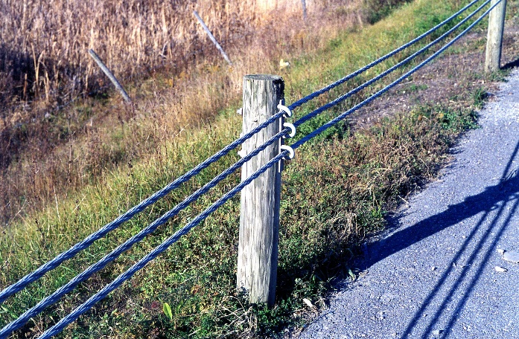**Why spray highway guardrail and at State airports?**

* Left uncontrolled, weeds can obstruct motorists’ views, make pedestrian movement unsafe, slow other maintenance operations, damage pavement and other road structures, and cause drainage and erosion problems
* Ensure ability to visually inspect for structural issues and ease of access to maintain guardrail
* Maintain visibility of reflectors for public safety and prevent the loss of sight distance, concealment of intersections and impaired vision at curves, hills, driveways and other critical areas
* Control the growth of woody vegetation along roads as their roots systems compromise pavement integrity

Photo: Roadside Guardrail

* Promote worker safety by controlling noxious weeds (poisonous plants) in areas workers are expected to access
* Economically more sustainable than mechanical methods of vegetation management

**What does our chemical usage look like over the years?**

* ***From 2010 – 2018:*** VTrans utilized contractors for all guardrail spraying and airport weed management
* ***From 2019 – 2020:*** VTrans utilized a retrofitted liquid salt/plow truck for highway guardrail and a smaller spray unit for airport fence-line spraying
* ***Present:*** VTrans Maintenance Bureau has received, and plans to implement two custom spray units to optimize guardrail spraying efficiency and save money in the long-run by cutting out contracted spraying and keeping the operation in house

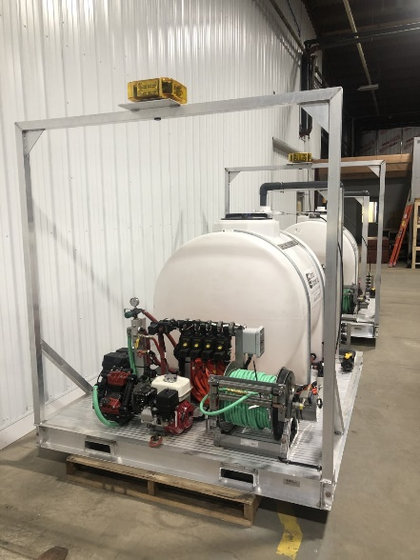**What’s new for this year?**

* Two new skid units made by Chemical Containers, Inc. out of Lake Wales, FL with mounting capabilities for our plow trucks
* Units have new electronics that will allow VTrans to better and more efficiently track chemical usage, map spray areas, and detect leaks or failures in the system
* Units will be assessed for the 2021 spray season and in the long-term, but overall, we will recoup the cost of them (**approx. $70,000/unit=$140,000**) within one year as compared to contracting out yearly spray services (**approx. $150,000/year**)
* Plan in place for potentially acquiring two additional units in 2022 for a total of four in order to achieve regional coverage of the state
* Acquiring and successfully implementing these new units will support our VTrans Pesticide Mission Statement of reducing chemical usage by seeking efficiencies in application, trainings, and technology

Photo: Chemical Containers, Inc. 525G Pesticide Skid Units